**Experiment-1 :**

Create a below Sign-up form in HTML

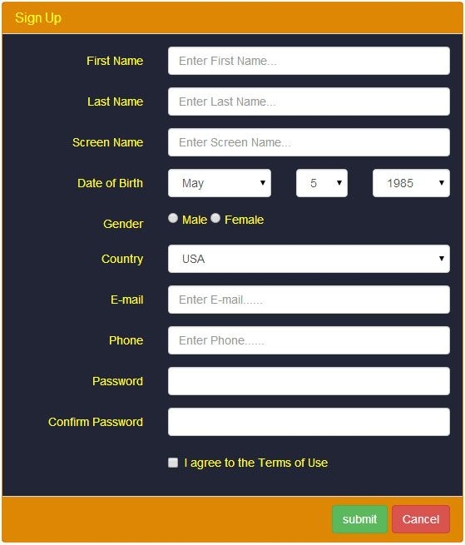

**Experiment-2:**

Create a below Webinar registration form.

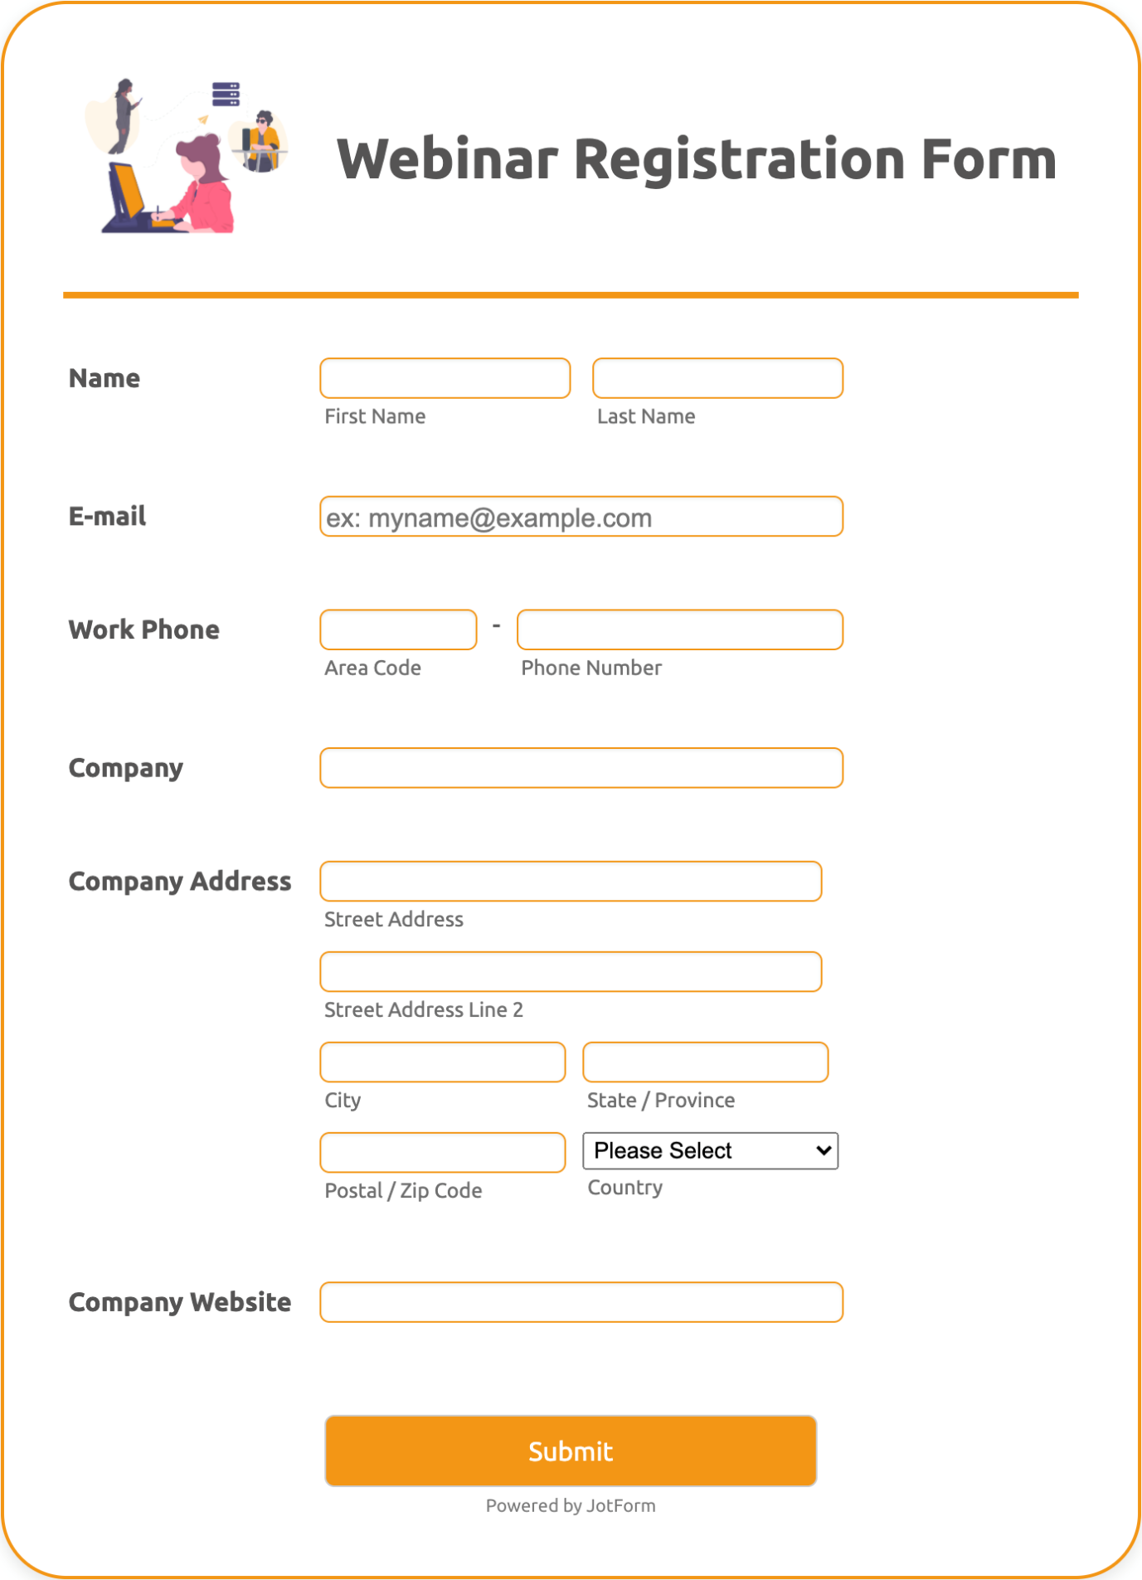

**Experiment-3:**

Create a login form and get validate the user with database.

